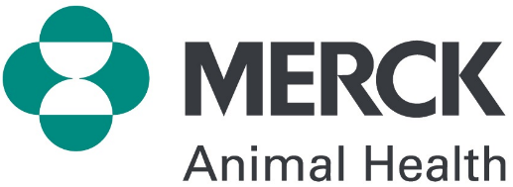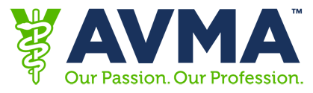

ANIMAL WELFARE ASSESSMENT CONTEST®
APPLICATION FORM
PLEASE PRINT OR TYPE

19th Annual Animal Welfare Assessment Contest
Application deadline: October 13, 2019
Applicants selected by: October 22, 2019

The AVMA with funding from Merck is pleased to offer assistance with travel expenses (transportation, lodging, meals) for veterinarians who are members of the AVMA in good standing and choose to participate in the November 2019 Animal Welfare Assessment Contest® to be held at Colorado State University, Fort Collins, CO on November 22-24, 2019. A maximum of eight $800 grants will be awarded, and advance application must be made using the form below. Reimbursement checks will be issued after submission of the appropriate receipts (an expense reporting form will be provided for you when you are notified that your application for a travel grant has been accepted).

Special thanks to Presenting Partner for providing funding and other resources in support of AWJAC®.

APPLICANT INFORMATION:

Name AVMA ID#

Address

Cell/Home Phone Email Address

Dates available for participation (check all that apply):

☐ Friday, November 22 ☐ Saturday, November 23 ☐ Sunday, November 24

Please tell us about your experiences in the application of animal welfare assessment:

Why are you interested in participating in animal welfare assessment?

APPLICANT REQUIREMENTS

Applicant represents that s/he:

- Holds a DVM degree or equivalent and a current license to practice veterinary medicine.
- Is an AVMA member in good standing.

APPLICANT SIGNATURE: By signing below, I certify that the information provided above is true and accurate to the best of my knowledge.

Signature of Applicant
By typing your name you agree that this is valid as your signature.

Email completed application and a current resume to awjac@avma.org. If selected, applicant agrees to submit a short narrative of their experience within 4 weeks of participation for AVMA’s use. For information on the AWJAC® program go to www.awjac.org.

